## BUILD A EMPLOYEE TRAVEL APPROVAL APPLICATION FOR CORPORATES

1 INDRODUCTION:

1.1 OVERVIEW

Another research revealed that travelers turn to a wide range of apps more regularly when they have a definite plan of where they need to go. Such users demand to be communicated on a regular basis via push messages, in-app chats, notifications sent before during and after the trip. These expectations present agencies with many opportunities to increase engagement.

These years users install tools not only to evaluate their choices but complete the target activity. 81.8% install-to-reserve rate supports this idea, revealing that users rely on a mobile/web solution to make a booking. Even though the value of such a transaction remains unknown, it is stated that the cost to acquire such a user is around $5.51

Creating business travel approval workflow is one of the most crucial steps in preparing the organization for an efficient and effective Business travel management system.  It offers many benefits concerning better traveler experience, reduced work burden for the travel admins desk and savings for the organization. The CFO’s usually form a small working group from the respective department; HR and Travel Admin to assess their current business travel workflow and redesign it.  However, the best advice can come from Corporate Travel Management Solutions providers who are experts in designing a process based on the best practices and the organization’s need for customization.

In today’s fast-paced world, enabling multiple device interfaces like mobile, laptop and tabs go a long way in offering convenience to the traveler and making the process faster.

1.2 PURPOSE

ACHIEVED BY THIS PROJECT

* Boost morale. The promise of a vacation to a hot destination, like San Diego, is usually enough to keep any employee’s morale high.
* Relieve stress. The vacations themselves also serve as a form of stress reliable
* Absence makes the heart grow fonder. No matter how fun and welcoming your office is, everyone needs some time away.
* Exposure to new cultures.

USES:

As our employee, you may need to **travel** for company purposes. This includes trips to: Meet with clients or partners. Attend events, like conferences, where you’ll represent our company. Visit our company’s offices in other locations. Conduct research or give talks/ lectures/ presentations on behalf of our company.

2 PROBLEM DEFINITION AND DESIGN THINKING

2.1 EMPATHY MAP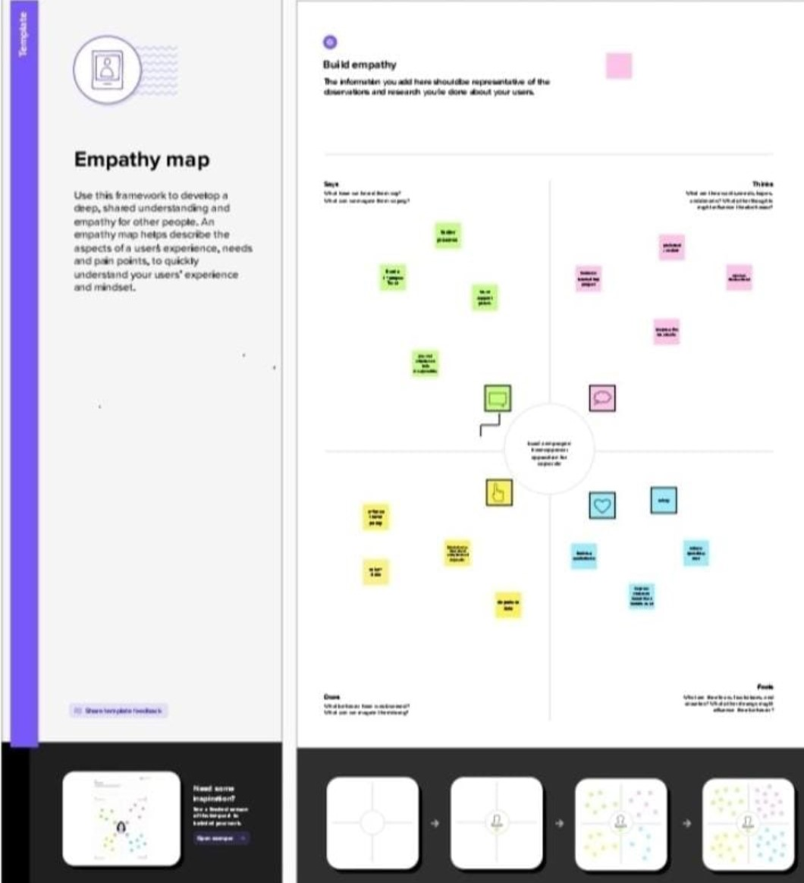

2.2 IDEATION AND BRAINSTORMING MAP:

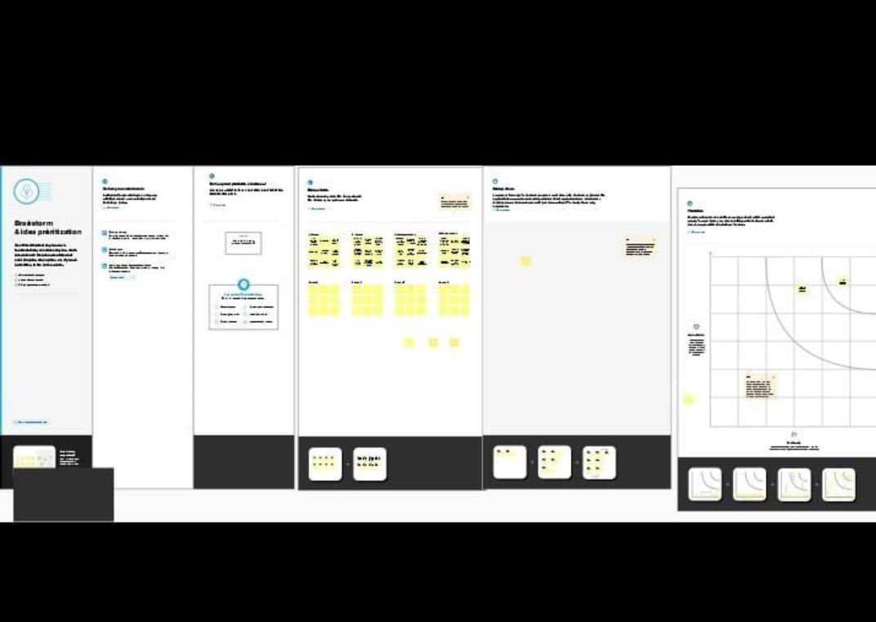

3. RESULT

3.1 DATA MODEL

|  |  |
| --- | --- |
| OBJECT NAME | FIELDS IN THE OBJECT |
| DEPARTMENT | |  |  | | --- | --- | | FIELD LABLE | DATA TYPE | | CREATED BY | LOOKUP(USER) | | DEPARTMENT | TEXT(80) | | OWNER | LOCKUP(USER,GROUP) | | TRAVEL REQUESTS | TEXT(67) | | TRIP END DATE | DATE | |
| TRAVEL APPROVAL | |  |  | | --- | --- | | FIELD LABEL | DATA TYPE | | CREATED BY | LOOKUP(USER) | | DEPARTMENT | TEXT(8) | | DESTINATION DATE | GEOLOCATION | | OUT OF STATE | GEOLOCATION | | TRAVEL APPROVAL# | AUTONUMBER | |

3.2 ACTIVITY AND SCREENSHOT

MILESTONES

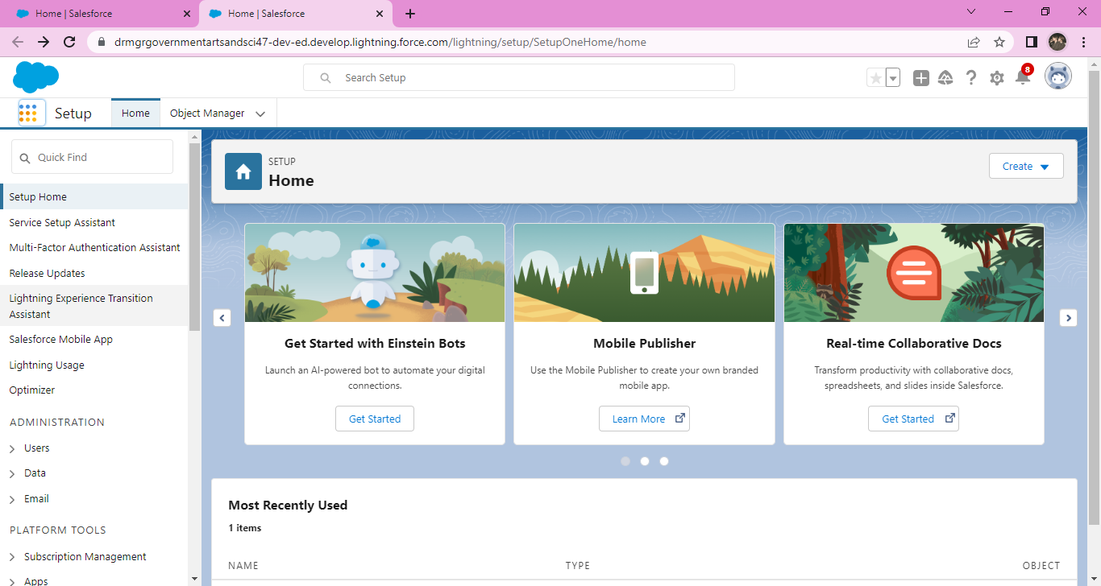

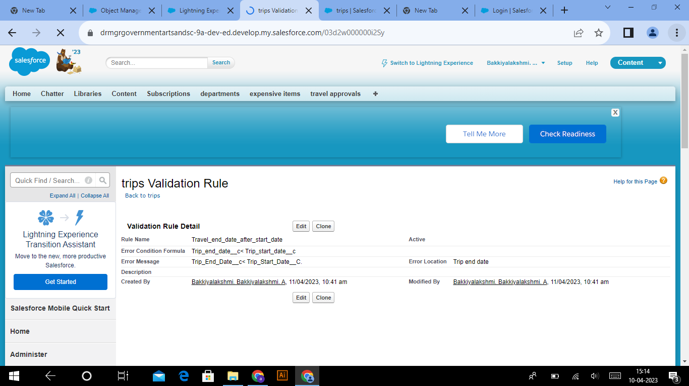

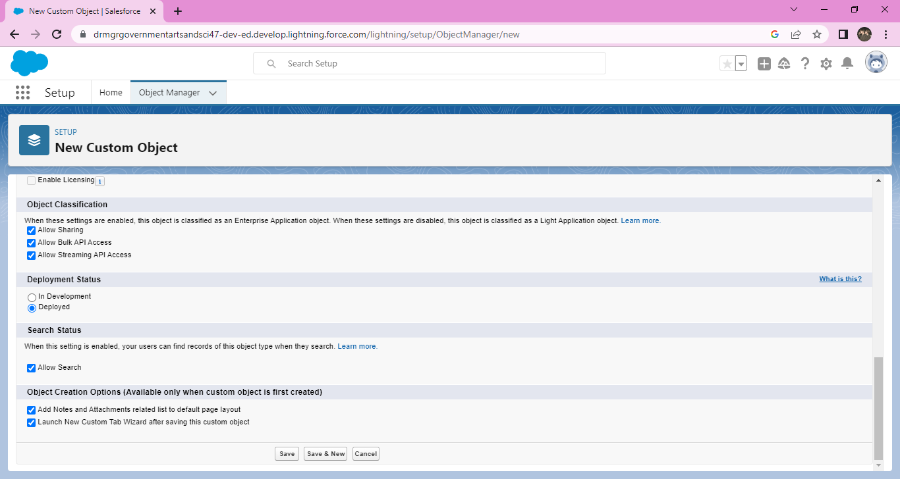

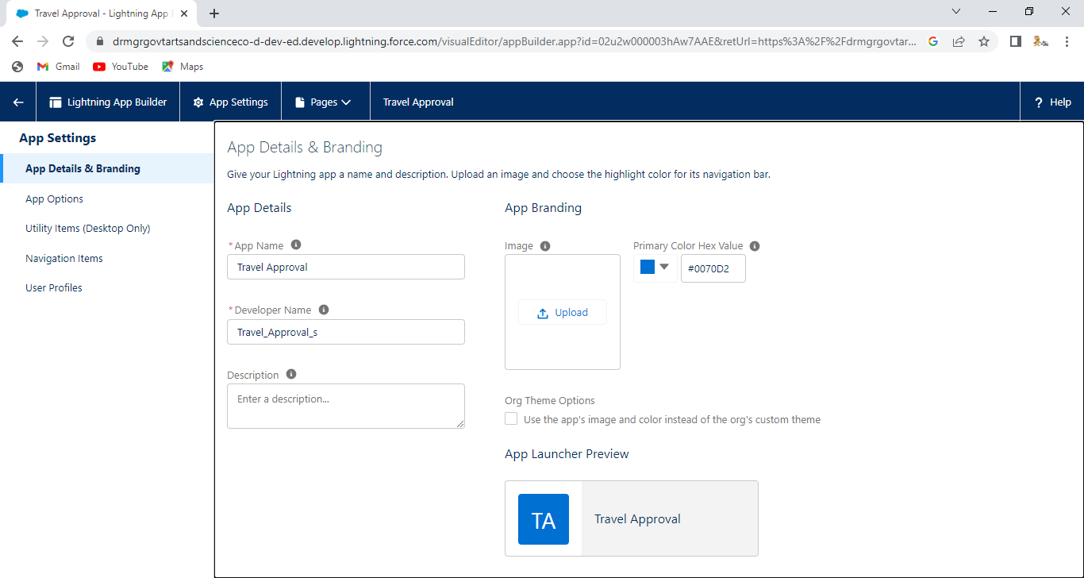

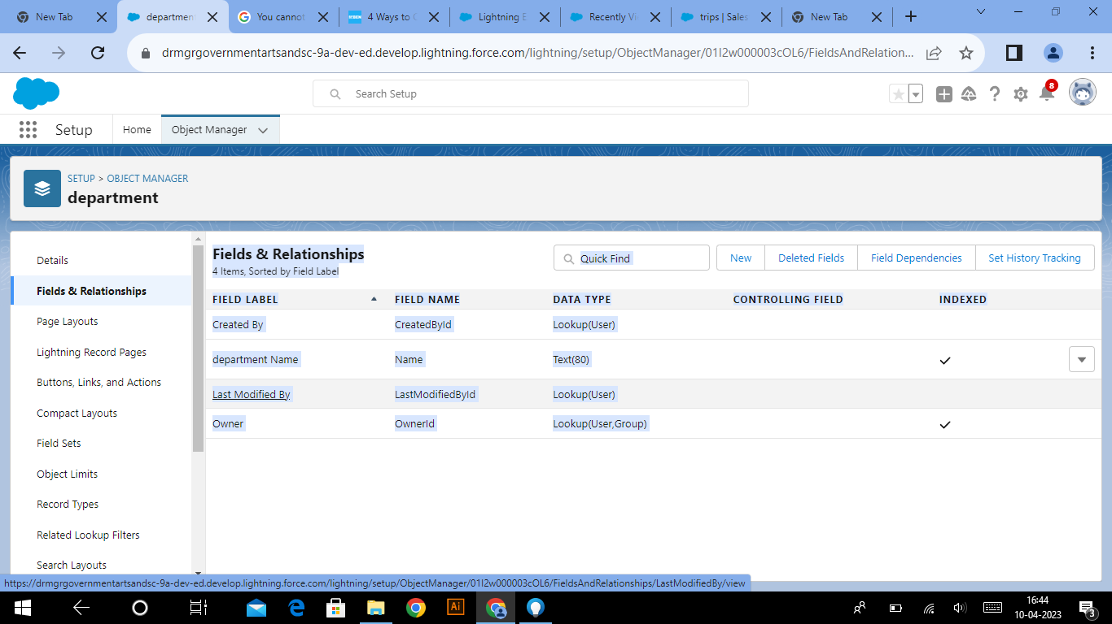

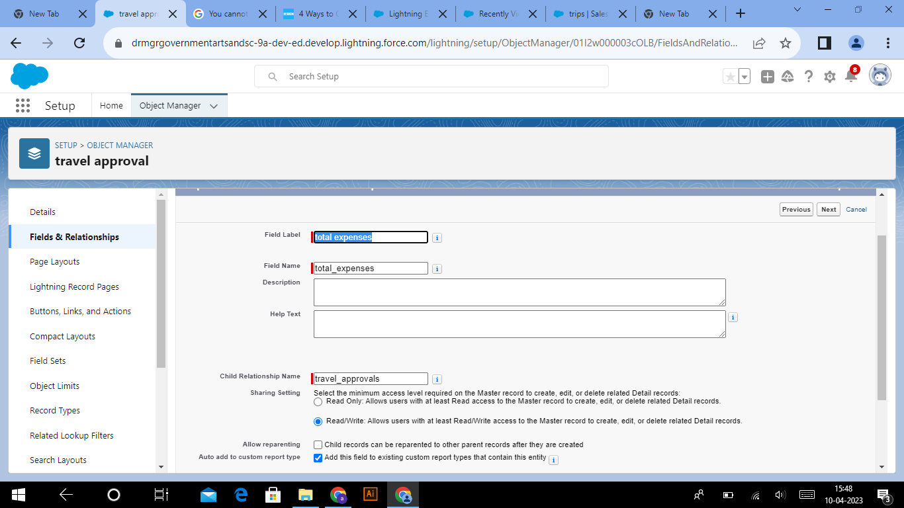

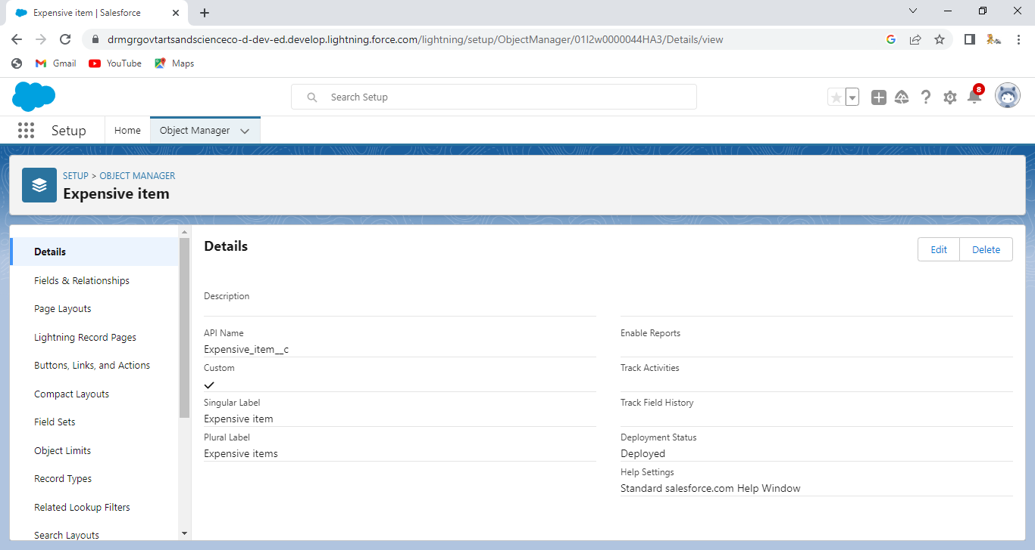

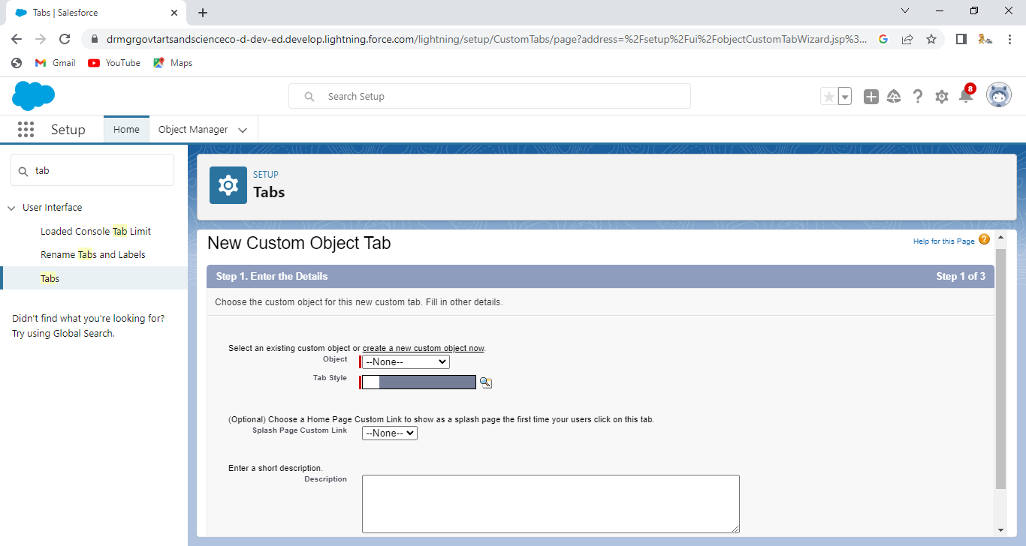

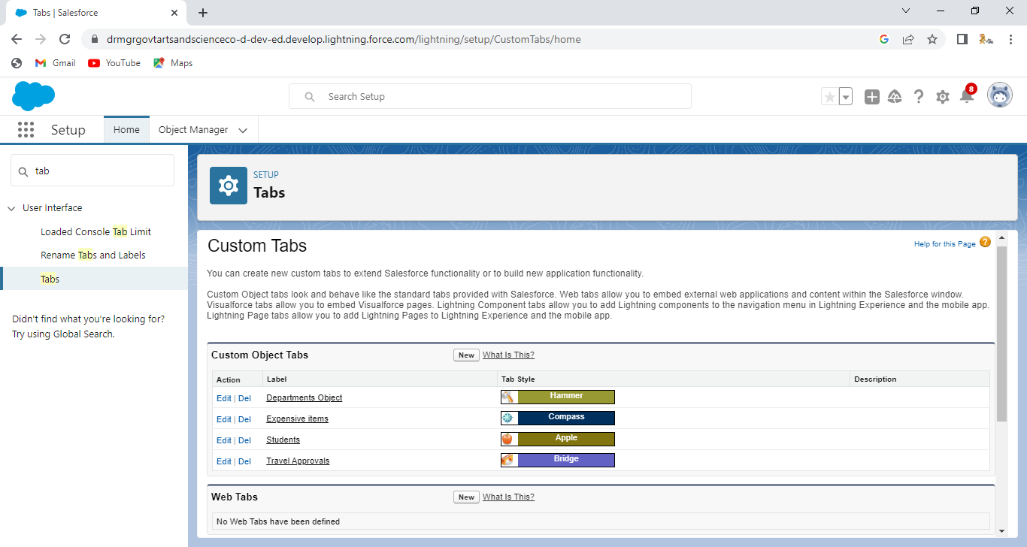

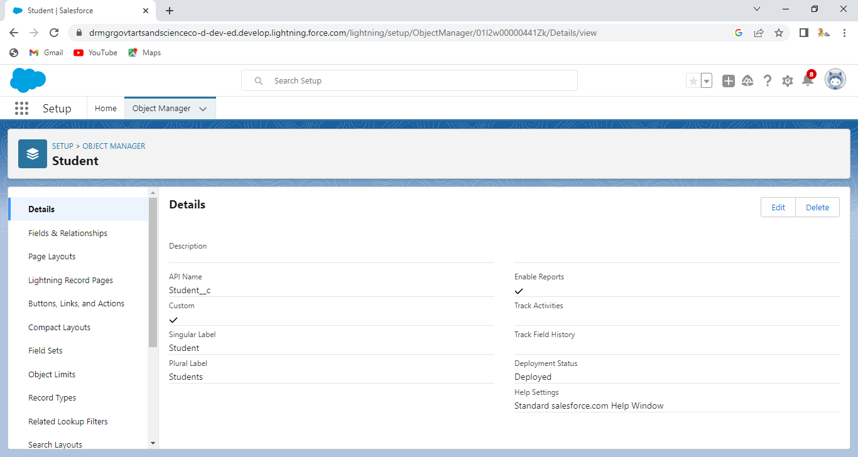

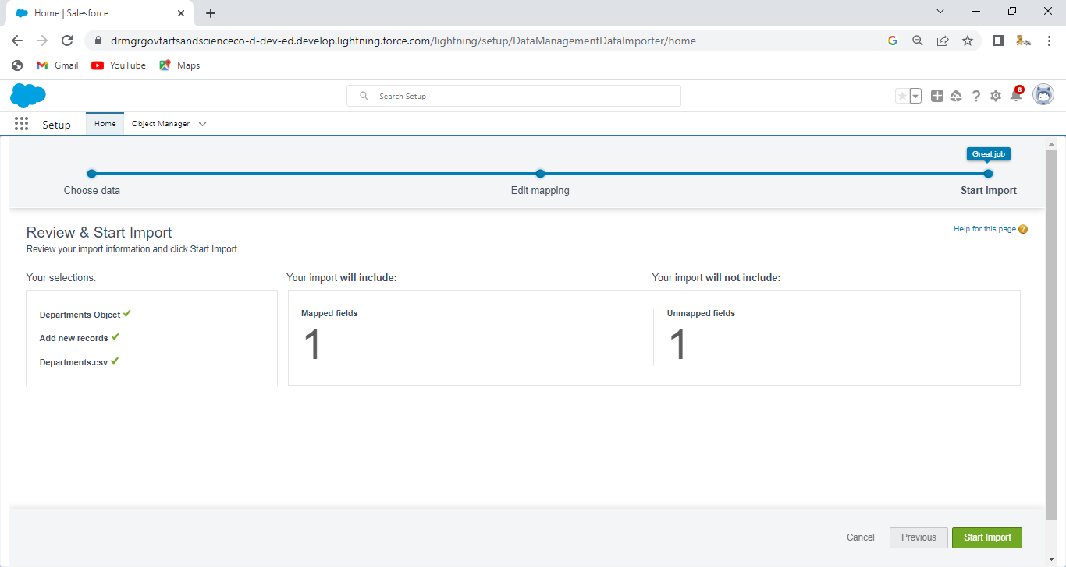

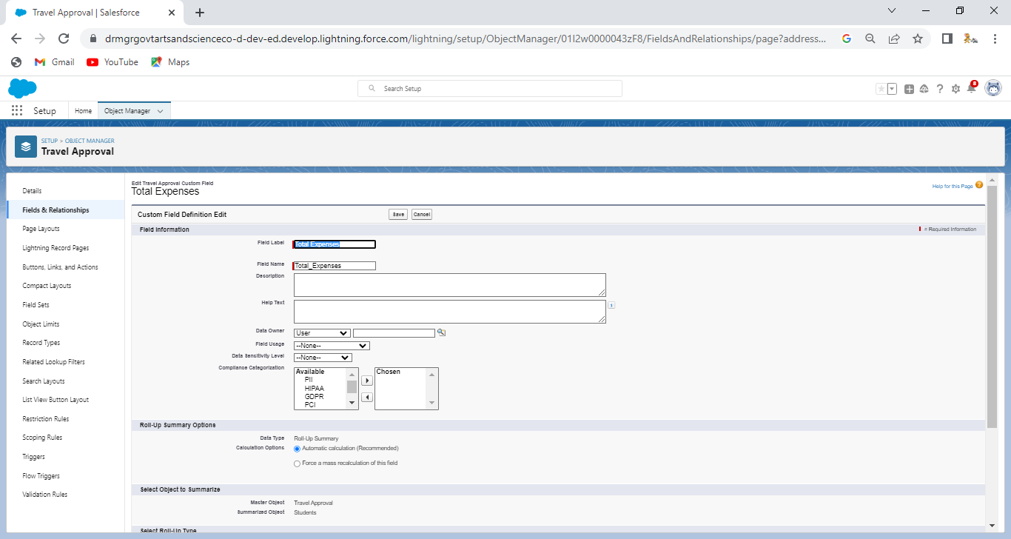

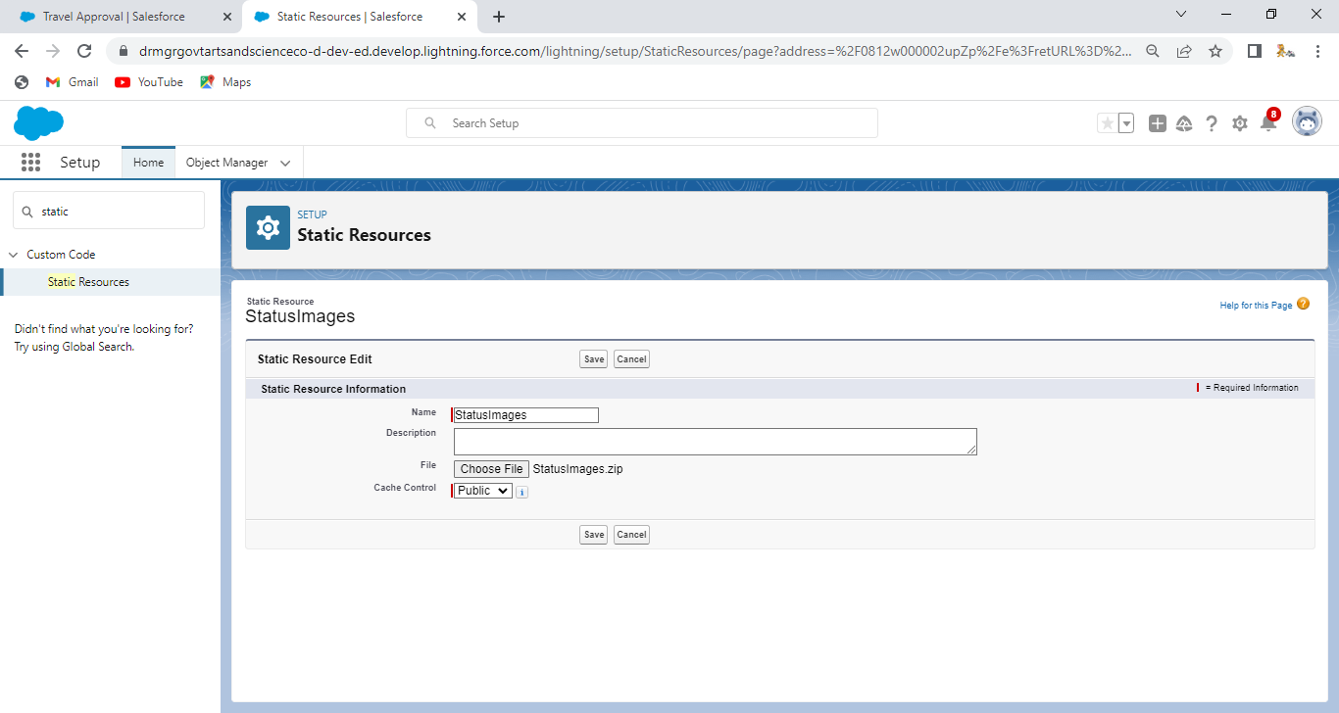

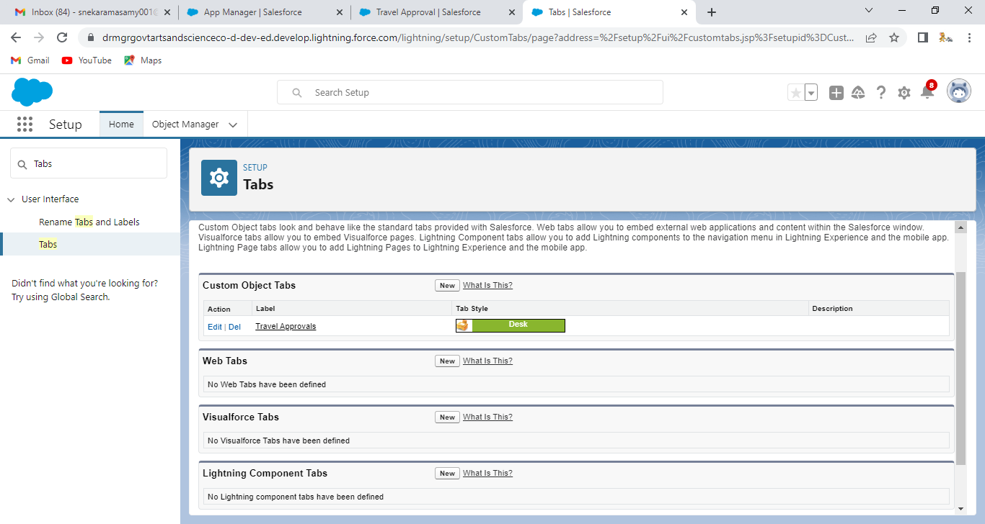

TEAM LEADER:[https://trailblazer.me/id/gosri4](https://trailblazer.me/id/gosri4%20%20%20%20)

TEAM MEMBER 1:<https://trailblazer.me/id/sjayaganth>

TEAM MEMBER 2:[https://trailblazer.me/id/ssupparmani](https://trailblazer.me/id/ssupparmani%20)

TEAM MEMBER 3 : [https://trailblazer.me/id/sramasamy44](https://trailblazer.me/id/sramasamy44%20)

TEAM MEMBER 4: [https://trailblazer.me/id/smathi104](https://trailblazer.me/id/smathi104%20)

5 ADVANTAGES AND DISADVANTAGES

Advantages and benefits of workplace travel plans. Operating a workplace travel plan can bring many benefits for your business and your staff. In particular, it will save your business money and reduce the impact it has on the environment eg by reducing CO2 emissions.

| METHOD | ADVANTAGES | DISADVANTAGES |
| --- | --- | --- |
| Internal recruitment | A quick process Applicants will alread… | Usually a small pool of applic… |
| External recruitment | May bring new ideas into the busines… | Takes time to settle into the b… |
| Recruitment agencies | Find high quality applicants Often a ... | Can be expensive to use Ma… |
| Media selection | Can be either cheap or expensive Ca… | Potential applicants may not … |

6 APPLICATIONS:

* providing travel
* reimbursing travel
* accommodation (if your employee needs to stay away overnight)
* meals and other ‘subsistence’ while travelling

7 CONCLUSION:

Travel motivates are the energizer of action, they are diverse and multifaceted.

Consequently, a range of researches and approaches may provide conflicting answers given that the behavior of tourists in pre,during and post travel are varied.

No simple explanation about why people take vacation,thus it is a process of understanding the psychology of tourist based upon the W’s and H questions – who,what, where, when,why and how.

Different types of tourist can have different characteristic.

8 FUTURE SCOPE:

This may include extended project work, shorter-term commuting arrangements and business travel. Naturally the scope varies from organisation to organisation depending on a number of factors, e.g. risk appetite, maturity of the program, existing business traveller processes and technology.